**NATIONAL INSTITUTE OF TECHNOLOGY KARNATAKA SURATHKAL**

**DEPARTMENT OF INFORMATION TECHNOLOGY**

**IT 301 Parallel Computing LAB 6**

**16th September 2020**

**Faculty: Dr. Geetha V and Mrs. Thanmayee**

**Name:** Chinmayi C. Ramakrishna

**Roll No.:** 181IT113

Write a parallel program (using Open MP) to convert a colour image to grayscale and YIQ. The RGB values (in decimal) are already extracted and stored in “KittenRGB.txt” file. Read the input values from the file.

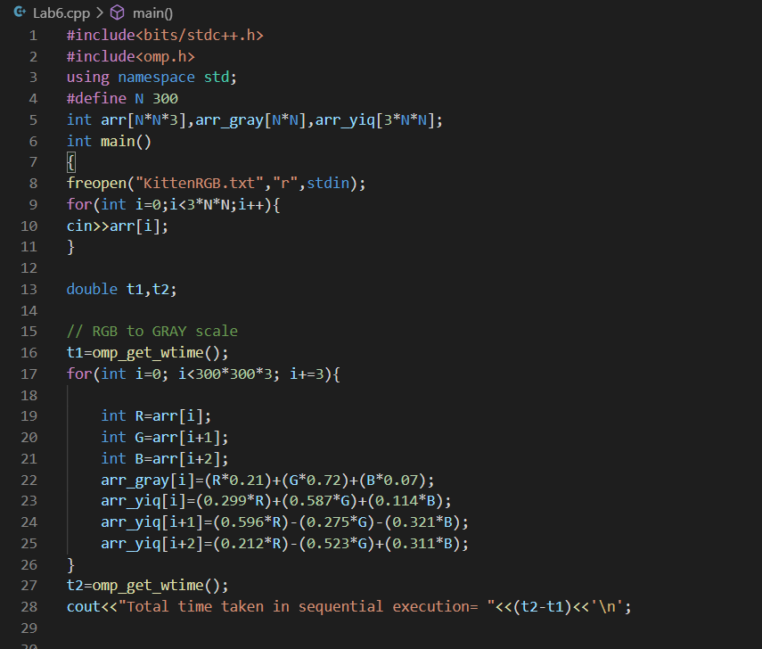

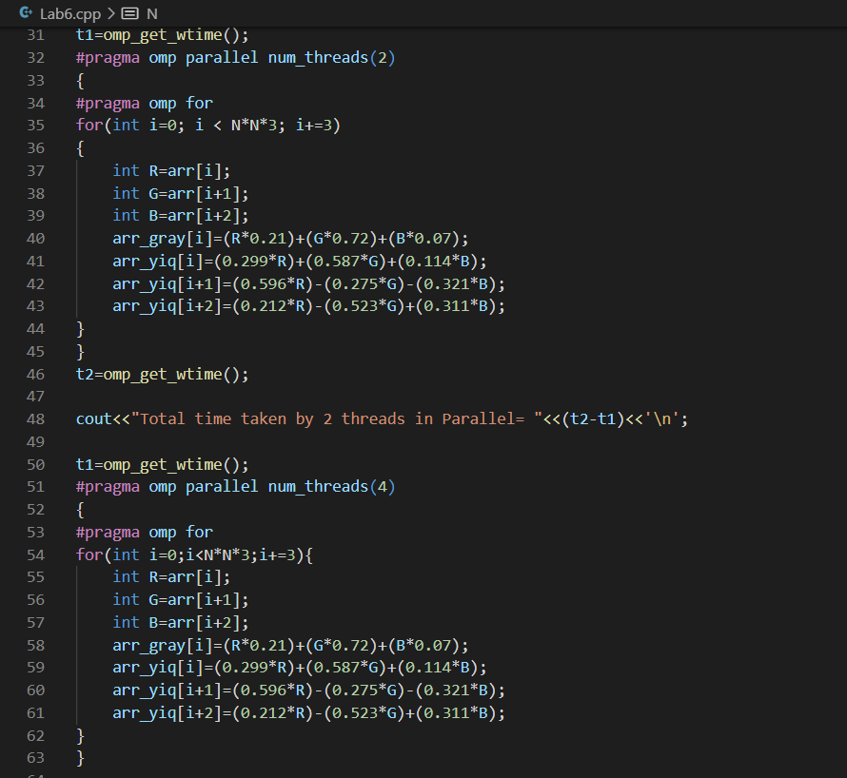

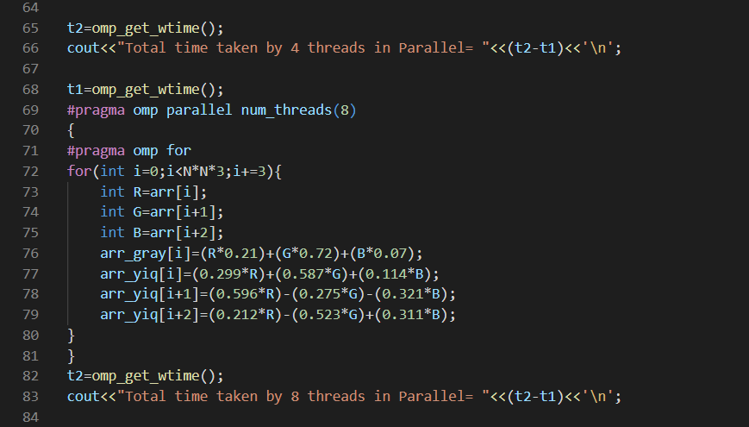

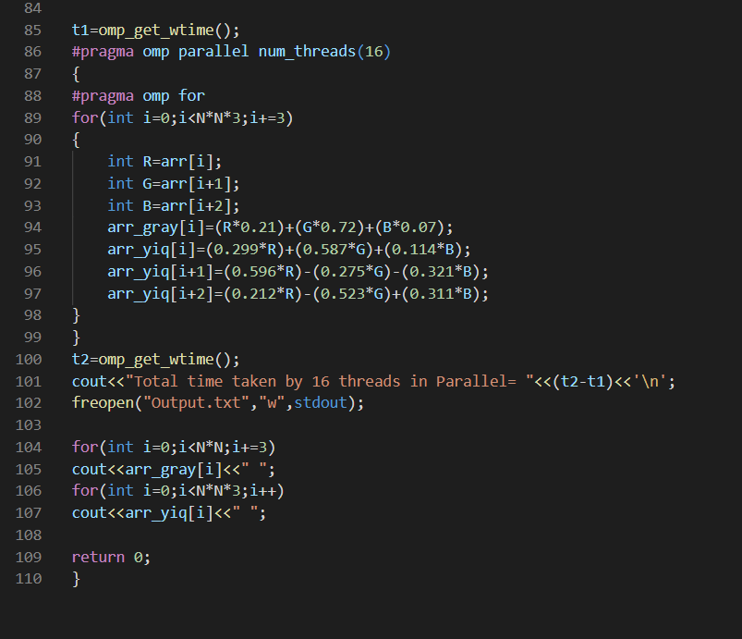

Output:

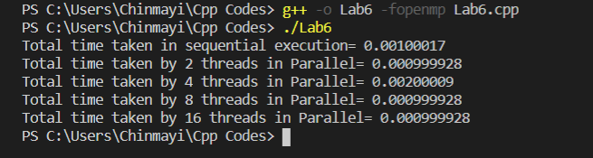

Parallel execution with more number of threads takes lesser time because work (iterations) is divided among different threads.

Output.txt containing grey scale values.

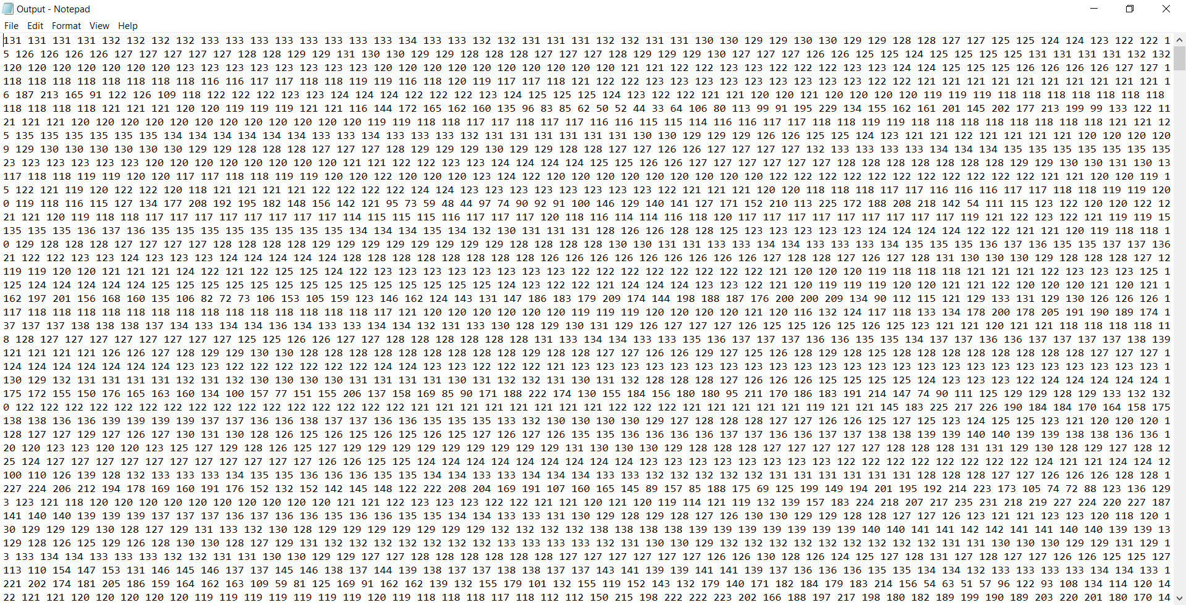

Output.txt containing YIQ values.

